* ***Code 1***
* 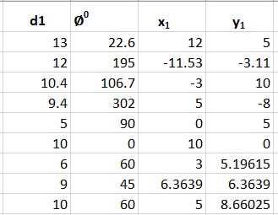
* ***Planner()***
* ***Case 1 : A straight line passing through origin***
* 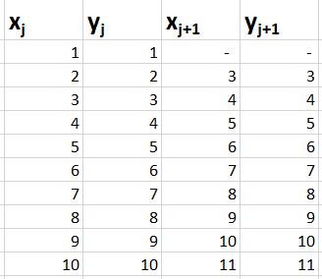
* ***Case 2: A line parallel to x axis, consider y =4***
* 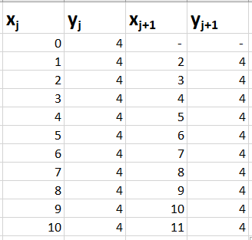
* ***Case 3 : A line parallel to y axis, consider x = 10***
* 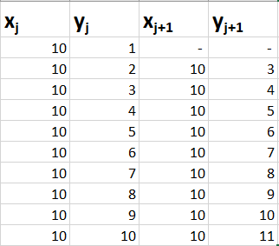
* ***Tracker()  
  For the following path of target, the positions of the chaser is as follows :  
  Example : Vc = 1.25***
* 